2021 Golden Acorn
Dinesh Natarajan Mohan

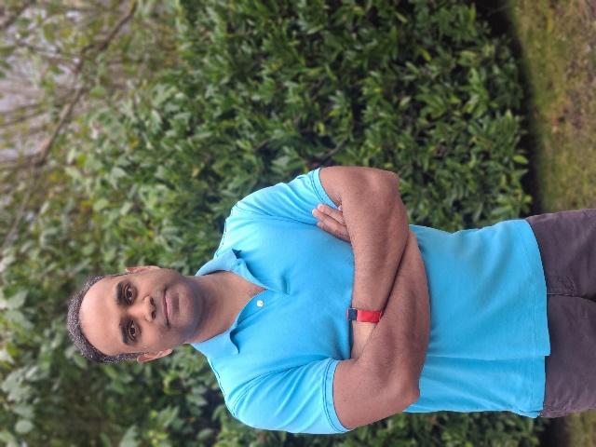

Dinesh graciously stepped into a rigorous PTSA board position during an incredibly difficult year and selflessly served our Endeavour community. As PTSA Treasurer, he has devoted his time and knowledge to helping the PTSA diligently manage our finances. He’s always available to file reports, cut checks and provide financial updates, and does so with professionalism and a smile.

He has humbly stepped into a huge role with the PTSA, and never expected praise or thanks. Dinesh is kind and considerate, and we are lucky to have him and his entire family in our Endeavour community.

We appreciate you Dinesh!

