2021 Outstanding Advocate
Meredith King

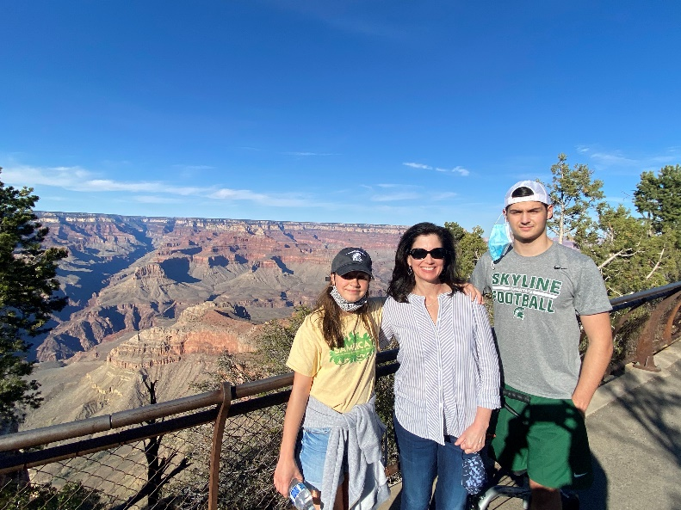

Meredith has devoted countless hours over the years volunteering to help the students and families at Endeavour, and this year was no different. After serving two years as the PTSA President, Meredith stepped up this year as the PTSA Advocacy Chair and continued to work diligently for our students. She worked throughout the year to keep the PTSA Board up to date on legislative issues that matter to our Endeavour community and provided ways to communicate to our elected officials to promote positive legislative changes for our district, school, and students.

Once we learned that our traditional Science Fair couldn’t happen this year, Meredith applied for and received a National PTA grant to hold a Science Festival for our students. Because of her hard work, over 500 science kits went home with our students, and kids were able to share the fun and excitement of science with their families at home! This was a bright spot in a difficult year, and we are indebted to Meredith for sparking joy for our students and families.
Meredith’s willingness to step in and fill any role, and her unwavering devotion to our Endeavour community have made her an irreplaceable asset to our school. Her grace, sense of calm and reason, and knack for always knowing how to handle any situation will be greatly missed when she and her family graduate from Endeavour this year.

Thank you, Meredith, for all your years of service!

