2021 Outstanding Educator
Danielle Figone

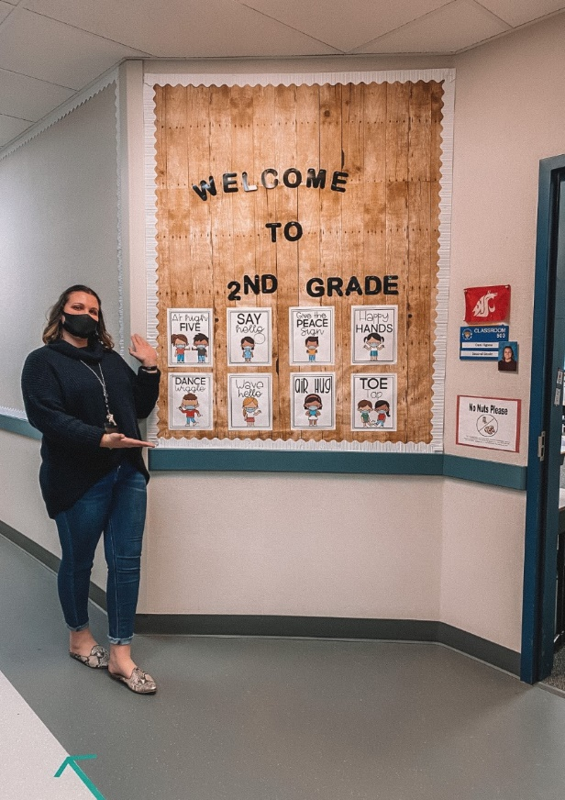

Ms. Figone has created a fun-filled educational environment for her second-grade students, despite the unusual circumstances of this school year. She is a fantastic educator, going above and beyond to connect with her students and their families. She is very approachable, replying instantly to any email communication, and providing information and recommendations from what to wear on picture day to what reading materials to concentrate on after school.

Ms. Figone really “gets” her students and develops a strong relationship with each child.
Each day begins and ends with a song, and Ms. Figone has come up with many ways to make her students feel special and develop a love of school. By throwing special parties, spotlighting a star of the week, hosting Fun Fridays with Breakout rooms, and delivering special baskets to each child’s home, Ms. Figone has exceeded expectations. Her students truly know how much she cares, and they are thriving in her class.

Ms. Figone is supportive, inclusive, and fun, and has been inspirational for her students and families. We are thrilled to have Ms. Figone’s energy and enthusiasm here at Endeavour, and her love of teaching is contagious!

Thank you, Ms. Figone, for being an exceptional educator!

