2021 Outstanding Educator
Khrisla Mulvany

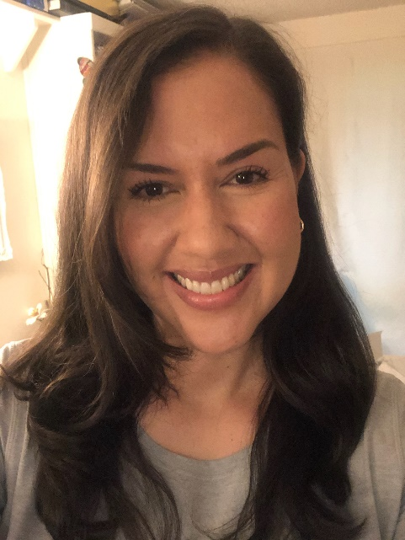

Ms. Mulvany has made an amazing pivot to teaching online for her 26 Merlin students this year! She makes sure to spend extra time with her students and is available for questions throughout the entire school day. She successfully encourages kids to cooperate in small groups as well as with the larger online class and makes learning fun by doing things like online trivia with her class.

Ms. Mulvany goes above and beyond for her students. She is engaging and caring, and not afraid to encourage her students to work harder. She has such a deep understanding for what each student needs both individually as well as in the group. She tirelessly works to make sure each student has been able to continue learning during this extremely stressful time.

Communication with parents is also a priority, and Ms. Mulvany is prompt about returning emails and answering questions. She is a true partner when working with parents to set students up for success.

Thank you, Ms. Mulvany, for your continued dedication to your students!

