2021 Outstanding Educator
Leah Skosky

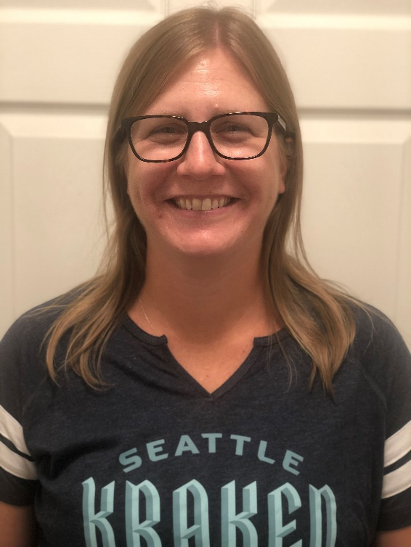

Ms. Skosky took over as a librarian at Endeavour a few years ago and singlehandedly transformed the library. She went through the entire book collection and pulled outdated and repeat books, replacing them with perfectly curated updated books that are relevant and important for this generation of Endeavour students. She reorganized the shelving system so that it made more logistical sense, and now students of all ages can find the books that they are looking for with ease.

Ms. Skosky is great at engaging the students with fun and important information, and it’s obvious that the kids enjoy all the creative projects that she provides. Students have benefitted from the optional book clubs, curbside library pick up, library lunches and virtual author visits that Ms. Skosky has organized this year.

In a year where students have needed ways to connect with each other, Ms. Skosky has helped create a sense of community and gone above and beyond to provide connections. Her dedication to the library and passion for reading shine brightly, and we are lucky to have her talents at Endeavour.

Thank you, Ms. Skosky, for sharing your love of reading with our Endeavour students!

